Slide the passenger’s side seat all the way forward and remove the 2 mounting screws at the base of the front seat.

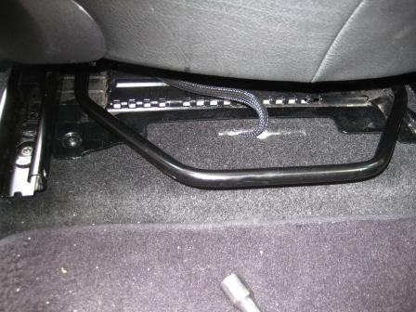
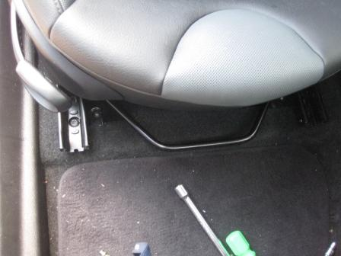

Now slide the seat all the way to the front and remove these to mounting screws. Now you can ease the seat forward and out of the way without disconnecting anything below the seat.
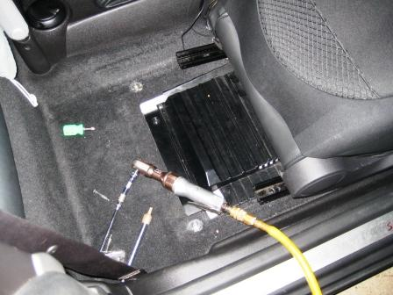
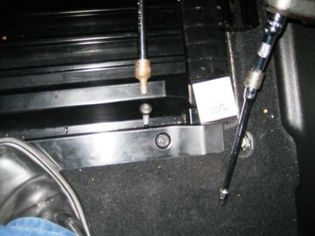

Remove the 2 rear phillips head screws in the plastic cover that was below the seat. Remove only the 2 back screws and leave the 2 front screws in place. If you loosen the front screws, It will be very difficult to get the screws back in place and the cover will get in the way when resetting the seat in it’s proper place.

A little clear packing tape is ideal to hold the cable in place next to the console where it will enter below the seat rails to the area below the plastic cover.
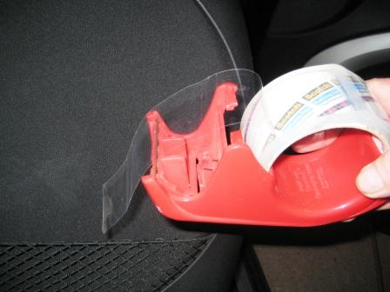
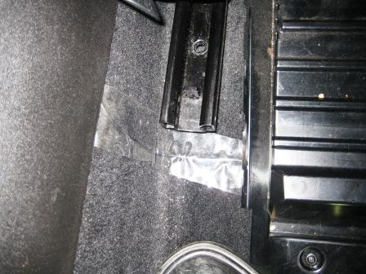

Pull the plastic cover up and find the Antenna termination. Plug the antenna extension in and route it up to the console and sliding it below the console route it forward to the area that you are mounting the radio. Now, reinstall the 2 phillips screws being sure to screw them straight down into their prior holes. Re align the seat and re install the rear mounting screws. Move the seat toward the rear and re install the front mounting bolts. At this point the hard part was over.
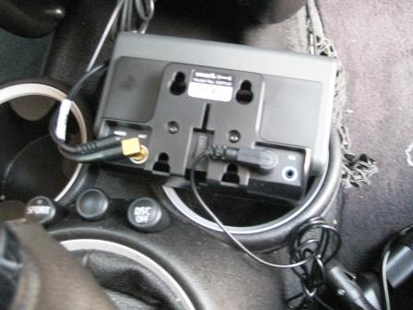
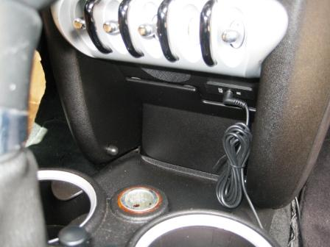

Stuff the antenna wire below the center console. (don’t be rough with it) and bring the termination out in the hole at the front of the console.. Connect the aux wiring to the area in the top of the front console area. Now connect the antenna, power, and aux wire to their proper places in the back of the radio.
I used a 2 into 1 power plug for this radio so I would have a plug for GPS. Not too fancy but functional.
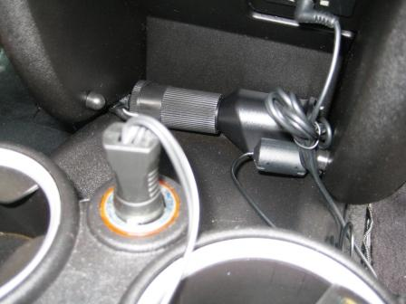
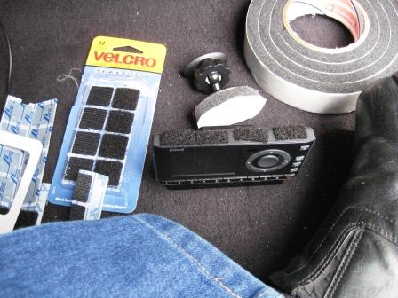

I used Velcro and the radio stand off and some foam insulating tape to mount the radio in place. It made for an acceptable mount arraignment and is fairly stable as long as you don’t start banging on it. You can see the Velcro at the top of the radio and the stand off at it’s base. I pushed all the excess wiring behind the radio and it appears like it might work for me.
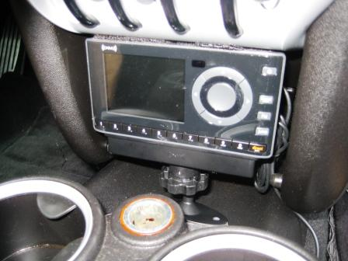
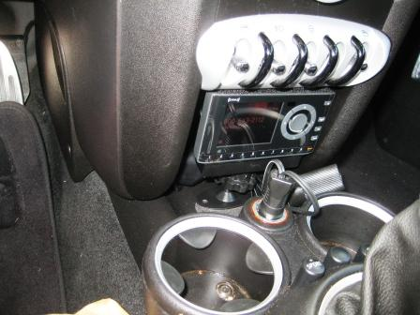

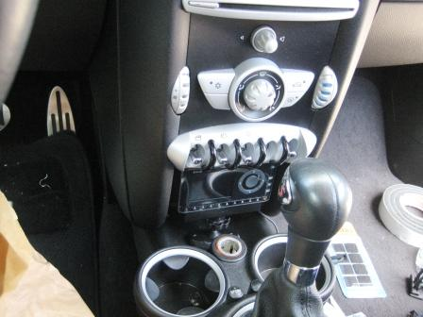

These pictures show a pretty dirty little car. I wasn’t aware of that but I’ll bet that I can get that fixed too.
These are just my ideas and the way that I did it. If it will work for you great, if not, well it’s still ok.

